

**GigSphere:  
 A Cohesive Sphere to Bridge Freelancers and Clients**

**21CSC205P – DATABASE MANAGEMENT SYSTEM**

**PROJECT REPORT  
(Review – 2)**

**B.Tech. CSE - CYBERSECURITY**

**SCHOOL OF COMPUTING**

**COLLEGE OF ENGINEERING AND TECHNOLOGY**

**SRM INSTITUTE OF SCIENCE AND TECHNOLOGY**

**(Under Section 3 of UGC Act, 1956)**

S.R.M. NAGAR, KATTANKULATHUR – 603 203 CHENGALPATTU DISTRICT

# **February 2025**

KIRONMOY MUKHERJEE (RA2311030010129)  
ADITYA KHANDELWAL (RA2311030010130)

**TABLE OF CONTENTS**

|  |  |  |
| --- | --- | --- |
| **S No.** | **Title** | **Page No.** |
| 1 | Introduction | 3 |
| 2 | Problem Statement |  |
| 3 | Abstract | 4 |
| 4 | Tech Stack | 5 |
| 5 | Existing Challenges | 6 |
| 6 | Listing of Entities | 7 |
| 7 | Code | 8 |
| 8 | Output | 8 |
| 9 | Diagrams | 10 |

**INTRODUCTION**

GigSphere is a complete freelance management system that helps optimize hiring and managing freelance experts. It offers a safe interface for freelancers and clients to work together, monitor progress, administer contracts, process payments, and settle conflicts. The system has features such as proposal submission, contract tracking, invoice creation, milestone payment, and user endorsements. Clients can list projects, view freelancer proposals, and hire experts on the basis of skills, while freelancers can search for work, send proposals, and track contracts. A formal system of endorsement improves reliability, enabling clients to identify freelancer ability through reviews and ratings.

The site comprises 16 basic entities, which are Users, Clients, Freelancers, Projects, Proposals, Contracts, Invoices, Payments, and Support Tickets. A Withdrawal process provides contract termination when required. GigSphere relies on a PostgreSQL database for scalability and data integrity, with API requests, payments, and authentication managed by a Python-Flask back-end. The front-end, created with HTML, CSS, and JavaScript, provides an intuitive user experience. With its strong architecture and secure financial management, GigSphere promotes trust, efficiency, and productivity in the gig economy.

**PROBLEM STATEMENT**

The freelance market is expanding, but efficient project management is still a problem. Conventional platforms lack organized contracts, milestone payments, and open dispute resolution, resulting in delays, mismanagement, and distrust. Clients find it difficult to identify trustworthy freelancers and monitor progress, while freelancers experience unjust contract modifications, payment disputes, and non-recognition.

GigSphere addresses these problems through proposal tracking, milestone payments, flexible contracts, and an endorsement-based credibility framework. Secure transactions, dispute resolution, and transparent work tracking create a fair and efficient freelancing experience for every user.

**ABSTRACT**

The independent industry is developing at a quick pace but handling projects continues to be tricky as a result of unorganized agreements, payment-related problems, and trust factors. Most sites center on advertisement posts and auctions but do not possess adequate solutions for tracking contracts, milestone payments, and solving disagreements. GigSphere addresses such challenges by presenting a full system of freelance administration to improve coordination, provide secure transactions, and ease project workflow processes.

GigSphere incorporates essential features such as proposal tracking, contract adaptability, milestone payments, and freelancer endorsements. Clients can publish projects, evaluate proposals, and hire freelancers, whereas freelancers can post bids, track contracts, and get paid securely. Dynamic contract management enables open-ended changes, avoiding disputes on project scope changes. Work submissions, endorsements, invoices, and support tickets further facilitate seamless operations. Developed using PostgreSQL, Flask, and a contemporary web interface, GigSphere provides an efficient and secure freelancing website that fosters efficiency and trust for everyone.

**TECH-STACK**(TENTATIVE)

|  |  |
| --- | --- |
| **CATEGORY** | **TECHNOLOGY** |
| FRONT END | HTML |
| CSS |
| JAVASCRIPT |
| BACK END | PYTHON (FLASK) |
| DATABASE | POSTGRE SQL |
| HOSTING | AWS/HEROKU |
| VERSION CONTROL | GITHUB |

**EXISTING CHALLENGES**

Several freelancing websites do not have an effective contract tracking system, which creates conflict regarding project scope, deadline, and compensation. In the absence of formal agreements, both clients and freelancers end up with misunderstandings and conflicts.

Payment delays are also a regular occurrence, since freelancers don't always receive payments on time or securely. The lack of milestone payments and escrow facilities means that clients can easily withhold or delay payments. Clients also often change project requirements, requiring freelancers to work overtime without adequate compensation or extension of deadlines.

Trust and credibility are also big issues. Without an endorsement system, freelancers can't demonstrate their expertise, and clients can't find reliable professionals. Most of these platforms do not have a formal work submission and approval procedure, leading to delays in completing projects and receiving payments.

Dispute resolution is also a problem. There are no defined mechanisms to manage contract breaches, scope creep, or payment defaults, leaving clients and freelancers with no adequate assistance. Financial monitoring is also limited, as most platforms lack transparent invoicing systems to monitor payments, taxes, and outstanding balances.

Finally, contract cancellation is usually rigid. When a project is no longer viable, neither clients nor freelancers have a formal method of terminating contracts without fines, which makes it hard to handle unforeseen circumstances smoothly.

**LIST OF ENTITIES IN PROJECT**

users{  
user_id PK  
username  
email  
user_type  
created_at  
password_hash  
}  
  
clients{  
client_id PK FK references users.user_id  
company_name  
business_type  
}  
  
projects{  
project_id PK  
client_id FK references clients.client_id  
title  
description  
budget  
deadline  
posted_at  
status  
}  
  
freelancers{  
freelancer_id PK FK references users.user_id  
bio  
portfolio  
experience  
hourly_rate  
}  
  
skills{  
skill_id PK  
skill_name  
}  
  
freelancer_skills{  
skill_id PK FK references skills.skill_id  
freelancer_id FK references freelancers.freelancer_id  
}  
  
proposals{  
proposal_id PK  
freelancer_id FK references freelancers.freelancer_id  
project_id references projects.project_id  
proposal_text  
bid_amount  
status  
submitted_at  
}  
  
  
reviews{  
review_id PK  
reviewer_id FK references user.user_id  
reviewee_id FK references user.user_id  
project_id FK references projects.project_id  
review_text  
rating  
review_date  
}  
  
endorsements{  
endorsement_id PK  
client_id FK references clients.client_id  
freelancer FK references freelancers.freelancer_id  
endorsement_text  
}  
  
contracts{  
contract_id PK  
client_id FK references clients.client_id  
freelancer_id FK references freelancers.freelancer_id  
project_id FK references projects.project_id  
proposal_id FK references proposals.proposal_id  
agreed_price  
start_date  
end_date  
status  
}  
  
contract_modification{  
modification_id PK  
contract_id FK references contracts.contract_id  
modified_by FK references users.user_id  
modified_at  
old_price  
new_price  
old_deadline  
new_deadline  
status  
}  
  
payments{  
payment_id PK  
contract_id FK references contracts.contract_id  
amount  
payment_method  
status  
}  
  
invoice_id{  
invoice_id PK  
contract_id FK references contracts.contract_id  
net_amount  
issued_at  
due_date  
status  
paid_at  
}  
  
submissions{  
submission_id PK  
submitted_by FK references freelancers.freelancer_id  
contract_id FK references contracts.contract_id  
description  
submitted_file  
submitted_at  
approved  
}  
  
withdrawals{  
withdrawal_id PK  
requested_by FK references users.user_id  
approved_by FK references users.user_id  
contract_id FK references contracts.contract_id  
reason  
status  
withdrawn_at  
}  
  
support_tickets{  
ticket_id PK  
raised_by FK references users.user_id  
created_at  
subject  
description  
status  
resolved_at  
}

**CODE**

**CREATING THE TABLES**

**INSERTING DATA INTO TABLES**

**OUTPUT**

**COMPLEX QUERIES**

SETS

Sets in SQL refer to collections of rows returned by queries. SQL provides set operations like UNION, INTERSECT, and EXCEPT to compare and combine results from multiple queries, similar to mathematical set theory.

* The first query uses UNION to combine two sets: users who are freelancers and users who are clients, labeling each with their role.
* The second query uses INTERSECT to find users who are both freelancers and have received endorsements—only those present in both sets.
* The third query uses EXCEPT to find freelancers who have listed skills but have never submitted a proposal—returning only those in the first set but not the second.
* The fourth query also uses EXCEPT, identifying projects that received proposals but haven't resulted in signed contracts.

VIEWS

In SQL, views are virtual tables created by saving a query under a name. They allow you to simplify complex joins and aggregations by encapsulating logic into reusable, queryable components.

* The project_proposal_count view shows each project along with how many proposals it has received. It joins projects with proposals and uses COUNT to tally proposals per project.
* The freelancer_skill_summary view lists each freelancer's username and a comma-separated list of their skills. It joins the freelancers, users, freelancer_skills, and skills tables, using STRING_AGG to format skills into a single string per user.
* The projects_without_submissions view identifies projects that have not received any submissions after being contracted and whose deadlines have already passed. It joins projects, contracts, and submissions using LEFT JOIN and filters for missing submissions and expired deadlines.
* The withdrawn_contracts_refund view calculates the total amount paid for each withdrawn contract (i.e., potentially refundable). It joins contracts with payments, sums up payments per contract using COALESCE to handle cases with no payments, and filters for contracts with the status 'withdrawn'.

CURSORS

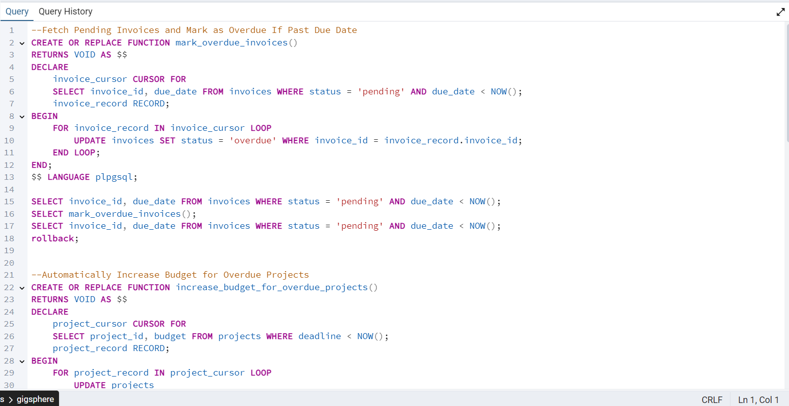

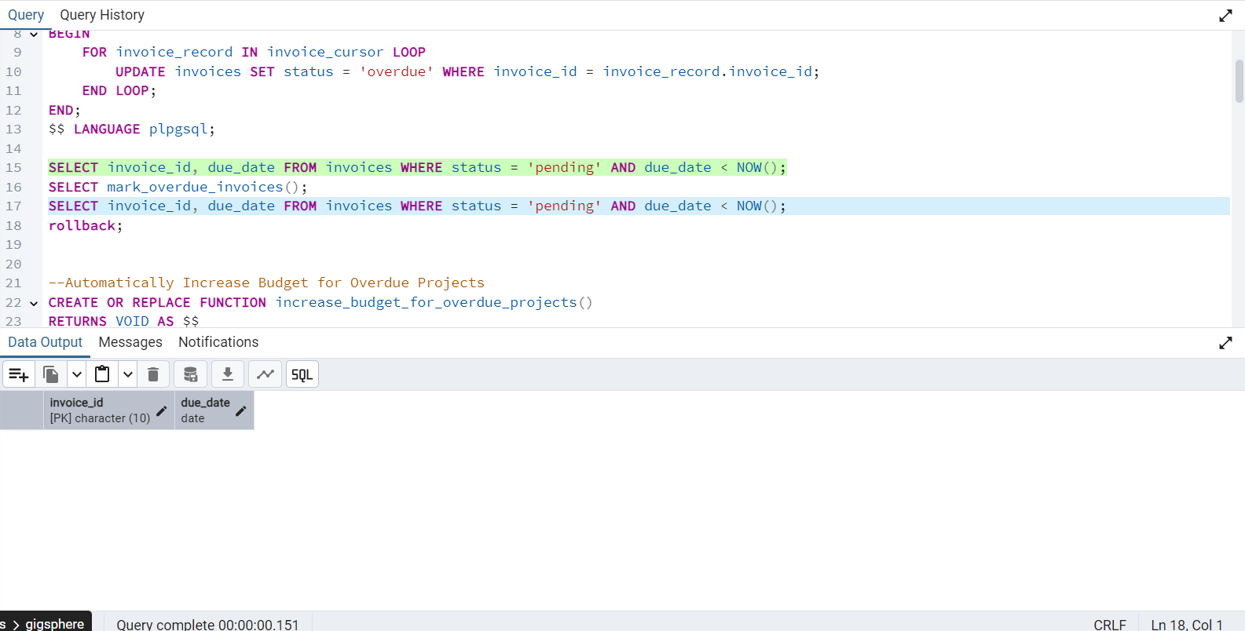

These PL/pgSQL functions automate database updates using cursors and loops to process multiple rows conditionally.

* mark_overdue_invoices(): Loops through all pending invoices past their due date and updates their status to 'overdue'.
* increase_budget_for_overdue_projects(): Increases the budget of all projects whose deadlines have passed by 10%.
* update_missing_project_status(): Sets the status of any project missing a status (NULL) to 'open'.
* close_completed_projects(): Updates projects that have passed their end date and are still marked 'open', changing their status to 'closed'.

TRIGGERS

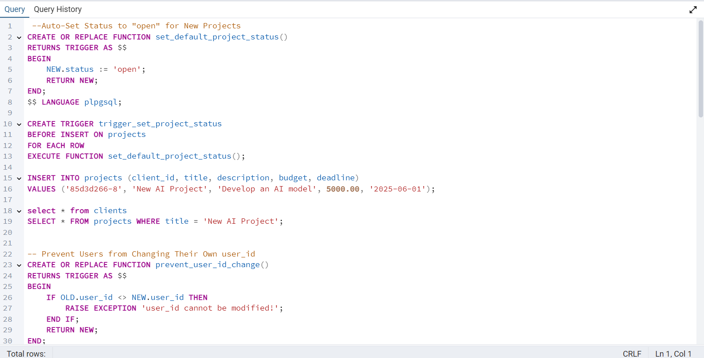

Triggers are special procedures in SQL that automatically execute in response to specific events (like INSERT, UPDATE, or DELETE) on a table.

* set_default_project_status(): Automatically sets the status of a new project to 'open' when inserted.
* prevent_user_id_change(): Prevents users from changing their own user_id by raising an exception during an update.
* update_invoice_on_payment(): Updates an invoice to 'paid' and sets the timestamp when a completed payment is inserted.
* enforce_minimum_bid(): Blocks any proposal where the bid_amount is less than the freelancer's hourly_rate.

**ER DIAGRAM**

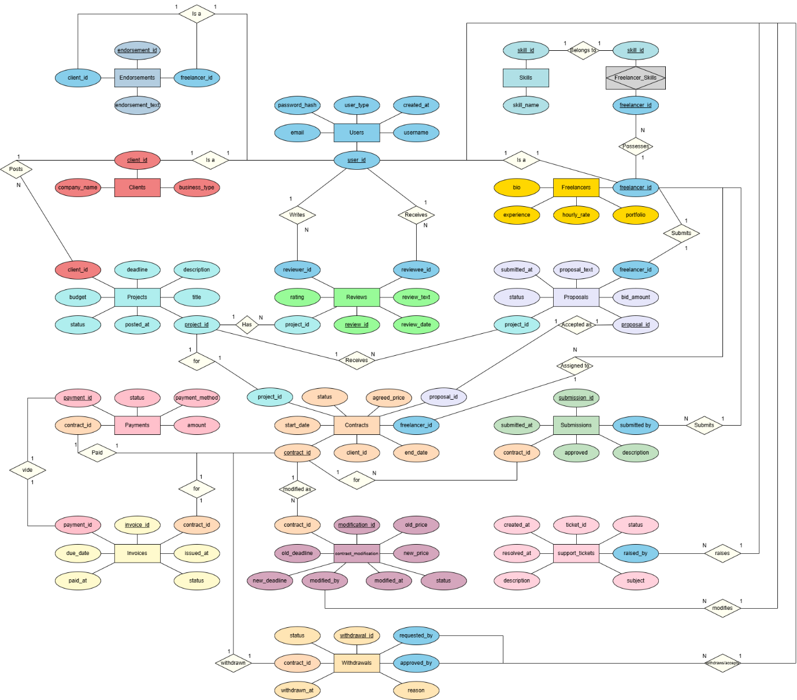

**RELATIONAL SCHEMA**

